AZ-900- Microsoft Azure Fundamentals

**Course agenda:**

**Module 1 - Cloud concepts (20-25%)**

* Lesson 1 - Introduction to Azure fundamentals
* Lesson 2 - Fundamental Azure concepts
* Lesson 3 - Module 1 Review Questions
* Lesson 4 - Module 1 Summary

**Module 2 - Core Azure services (15-20%)**

* Lesson 1 - Core Azure architectural components
* Lesson 2 - Core Azure workload products
* Lesson 3 - Azure networking services
* Lesson 4 - Azure storage services
* Lesson 5 - Azure database services
* Lesson 6 - Module 2 Review Questions
* Lesson 7 - Module 2 Summary

**Module 3 - Core solutions and management tools (10-15%)**

* Lesson 1 - Choose the best Azure IoT service
* Lesson 2 - Choose the best AI service
* Lesson 3 - Choose the best Azure serverless technology
* Lesson 4 - Choose the best tools with DevOps and GitHub
* Lesson 5 - Choose the best management tools
* Lesson 6 - Choose the best Azure monitoring service
* Lesson 7 - Module 3 Review Questions
* Lesson 8 - Module 3 Summary

**Module 4 - General security and networking features (10-15%)**

* Lesson 1 - Security Tools and Features
* Lesson 2 - Secure Network Connectivity
* Lesson 3 - Module 4 Review Questions
* Lesson 4 - Module 4 Summary

**Module 5 - Identity, Governance, Privacy, and Compliance (20-25%)**

* Lesson 1 - Core Azure identity services
* Lesson 2 - Azure Governance Methodologies
* Lesson 3 - Privacy, Compliance, and Data Protection standards
* Lesson 4 - Module 5 Review Questions
* Lesson 5 - Module 5 Summary

**Module 6 - Azure Pricing and Lifecycle (10-15%)**

* Lesson 1 - Planning and Cost Management
* Lesson 2 - Azure Service Level Agreements (SLAs) and Lifecycle
* Lesson 3 - Module 6 Review Questions
* Lesson 4 - Module 6 Summary

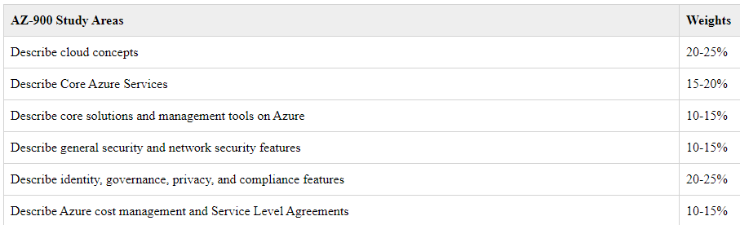

What is cloud computing?

Have you ever wondered what cloud computing is? It's the delivery of computing services over the internet, which is otherwise known as the cloud. These services include servers, storage, databases, networking, software, analytics, and intelligence. Cloud computing offers faster innovation, flexible resources, and economies of scale.

What is Azure?

Azure is a continually expanding set of cloud services that help your organization meet your current and future business challenges. Azure gives you the freedom to build, manage, and deploy applications on a massive global network using your favorite tools and frameworks.

What does Azure offer?

**Be ready for the future:** Continuous innovation from Microsoft supports your development today and your product visions for tomorrow.

**Build on your terms:** You have choices. With a commitment to open source, and support for all languages and frameworks, you can build how you want and deploy where you want to.

**Operate hybrid seamlessly:** On-premises, in the cloud, and at the edge--we'll meet you where you are. Integrate and manage your environments with tools and services designed for a hybrid cloud solution.

**Trust your cloud:** Get security from the ground up, backed by a team of experts, and proactive compliance trusted by enterprises, governments, and startups.

**How does Azure work?**

Azure uses a technology known as Virtualization. Virtualization separates the tight coupling between a computer's hardware and its operating system, using an abstraction layer called a hypervisor. And the hypervisor emulates all the functions of a real computer and its CPU in a Virtual Machine. It can run multiple Virtual Machines at the same time, optimize the capacity of the obstructed hardware, and each Virtual Machine can run any compatible operating system, such as Windows or Linux. So Azure takes this virtualization technology and repeats it on a massive scale in Microsoft data centers throughout the world. Each data center has mini racks filled with servers, and each server includes a hypervisor to run multiple Virtual Machines. A network switch provides connectivity to all of those servers. And one server in each rack runs a special piece of software called a Fabric Controller. Each Fabric Controller is connected to another special piece of software known as the Orchestrator. So the Orchestrator is responsible for managing everything that happens in Azure, including responding to user requests. And users make requests using the Orchestrators Web API. The Web API can be called by many tools, including the user interface of the Azure portal. So, when a user makes a request to create a Virtual Machine,

the Orchestrator packages everything that's needed, picks the best server rack, and then sends the package and request to the Fabric Controller. Once the Fabric Controller has created the Virtual Machine, the user can connect to it. Azure makes it easy for developers and IT administrators to be agile

when they build, deploy, and manage their applications and services. In fact, building a Virtual Machine is just the beginning with Azure's ever expanding set of cloud services to help you meet your business challenges. It gives you the freedom to build, manage, and deploy applications on a massive global network, using your favorite tools and frameworks.

**What is the Azure portal?**

The Azure portal is a web-based, unified console that provides an alternative to command-line tools. With the Azure portal, you can manage your Azure subscription by using a graphical user interface. You can:

* Build, manage, and monitor everything from simple web apps to complex cloud deployments.
* Create custom dashboards for an organized view of resources.
* Configure accessibility options for an optimal experience.

The Azure Portal is your one-stop, graphical management solution for creating, configuring,

and controlling all your Azure services and subscriptions. The Portal makes it easy to create resources through a wizard-like environment, from something as simple as a website, to a geographically-redundant database, to a full Kubernetes cluster. Once you have resources created, the Portal lets you adjust the various parameters and settings for your resources, add users to your cloud-based active directory, implement security policies, and plan back-up schedules. You can personalize your Portal experience

through custom dashboards that you create, to see the data that is most important to you. Within the Portal, you can start and stop services, as needed. You can scale your services by adding or removing resources from your subscription, according to your business needs. You can also monitor the health of your applications, track your costs and billing status, analyze the performance of your applications in real-time, or create reports for in-depth analysis. The Azure Portal is your gateway to managing everything in your Azure subscription. Whether you are creating new resources, configuring existing resources, or controlling Azure services, the Azure Portal is your place to manage your company's business on Azure.

**What is Azure Marketplace?**

[Azure Marketplace](https://azuremarketplace.microsoft.com/?azure-portal=true) helps connect users with Microsoft partners, independent software vendors, and startups that are offering their solutions and services, which are optimized to run on Azure. Azure Marketplace customers can find, try, purchase, and provision applications and services from hundreds of leading service providers. All solutions and services are certified to run on Azure.

**Tour of Azure services**

Azure can help you tackle tough business challenges. You bring your requirements, creativity, and favorite software development tools. Azure brings a massive global infrastructure that's always available for you to build your applications on.

Let's take a quick tour of the high-level services Azure offers.

Microsoft Azure has such an extensive array of services and features. How can you wrap your head around them all? We'll try to help you here by breaking them down into 10 main categories.

Compute.

These cloud services let you scale your computing capability on demand while only paying for what you use. Add virtual machines as needed or scale your company's app services for web and mobile apps.

Networking.

These features let you connect your cloud and on-premise infrastructure in order to bring the best possible experience to your customers. VPNs and load balancing are just two examples of these features.

Storage.

Whether it's disk, file, blob, or archival storage, these services let you scale your data and app storage needs in a secure fashion.

Mobile.

With the mobile services, you can build and deploy cross-platform and native apps for any mobile device, send notifications, use Xamarin to build cloud-powered apps, and take advantage of cognitive services to make your app smarter.

Databases.

Choose from a variety of proprietary and open source database engines to bring your current databases to the cloud. Use tools to manage your SQL, Cosmos DB, MySQL, and other data services.

Web.

These services help you build, deploy, manage, and scale your web applications. Create web apps, publish APIs to your services, or use Azure Maps to provide geospatial context to your data.

Internet of Things.

Use these features to connect, monitor, and manage all of your IoT assets. Analyze the data as it arrives from sensors and then take meaningful action with it.

Big data.

When you have large volumes of data, these open source cluster services will help you run analytics at a massive scale and make decisions based off of complex queries.

AI.

Use your existing data to forecast future behaviors based on these AI services. Use machine learning to build, train, and deploy models to the cloud.

DevOps.

DevOps brings together people, processes, and technology by automating software delivery to provide continuous value to your users. With Azure DevOps, you can create, build, and release pipelines that provide continuous integration, delivery, and deployment for your applications.

These categories represent just a small fraction of what is available in Azure. Fortunately, it's easy to try out a new service, then mix and match them to get exactly what you need. And the best part is you only pay for what you use.

**Azure services**

Here's a big-picture view of the available services and features in Azure.

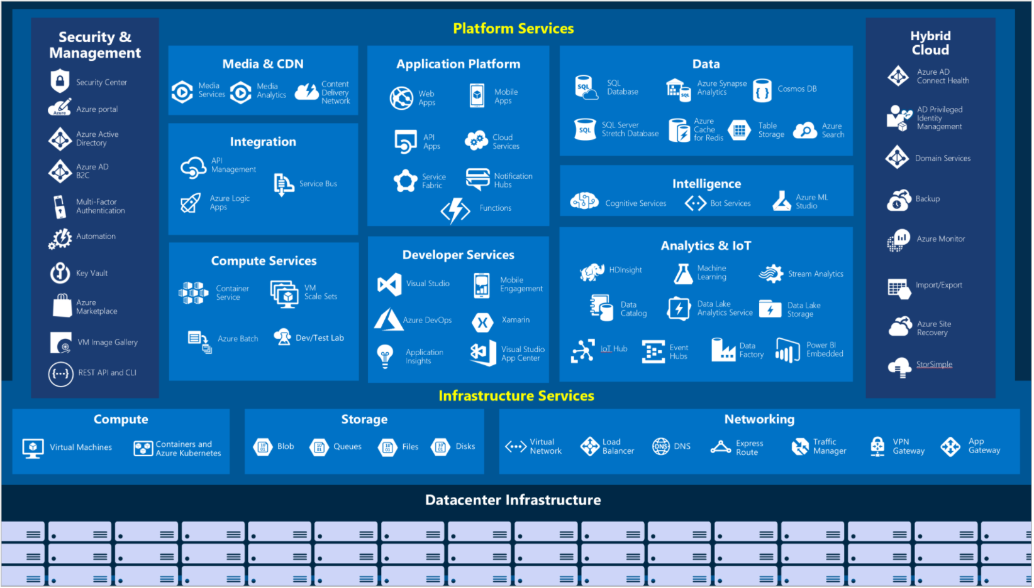

Let's take a closer look at the most commonly used categories:

Compute

Compute services are often one of the primary reasons why companies move to the Azure platform. Azure provides a range of options for hosting applications and services. Here are some examples of compute services in Azure.

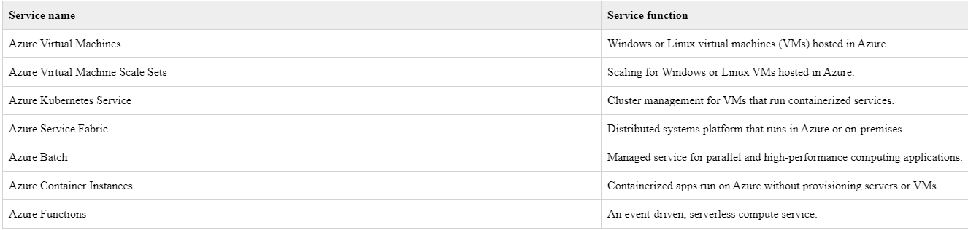

Networking

Linking compute resources and providing access to applications is the key function of Azure networking. Networking functionality in Azure includes a range of options to connect the outside world to services and features in the global Azure datacenters.

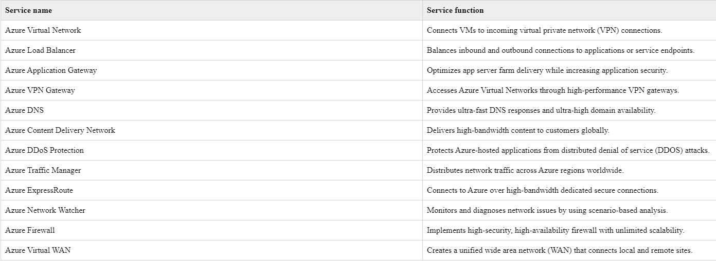

Storage

Azure provides four main types of storage services.

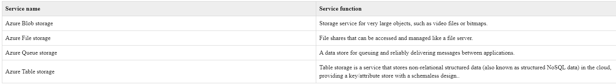

These services all share several common characteristics:

* **Durable** and highly available with redundancy and replication.
* **Secure** through automatic encryption and role-based access control.
* **Scalable** with virtually unlimited storage.
* **Managed**, handling maintenance and any critical problems for you.
* **Accessible** from anywhere in the world over HTTP or HTTPS.

Mobile

With Azure, developers can create mobile back-end services for iOS, Android, and Windows apps quickly and easily. Features that used to take time and increase project risks, such as adding corporate sign-in and then connecting to on-premises resources such as SAP, Oracle, SQL Server, and SharePoint, are now simple to include.

Other features of this service include:

* Offline data synchronization.
* Connectivity to on-premises data.
* Broadcasting push notifications.
* Autoscaling to match business needs.

Databases

Azure provides multiple database services to store a wide variety of data types and volumes. And with global connectivity, this data is available to users instantly.

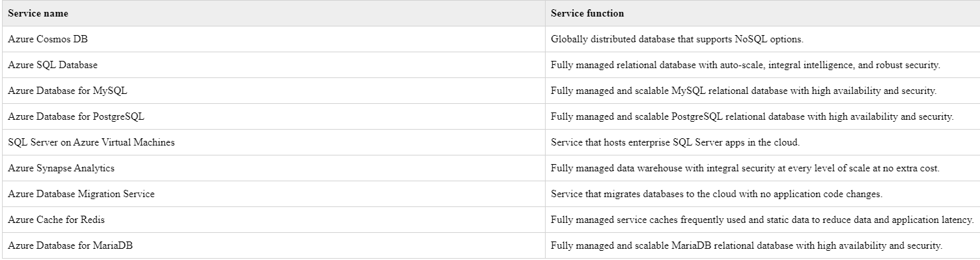

**Web**

Having a great web experience is critical in today's business world. Azure includes first-class support to build and host web apps and HTTP-based web services. The following Azure services are focused on web hosting.

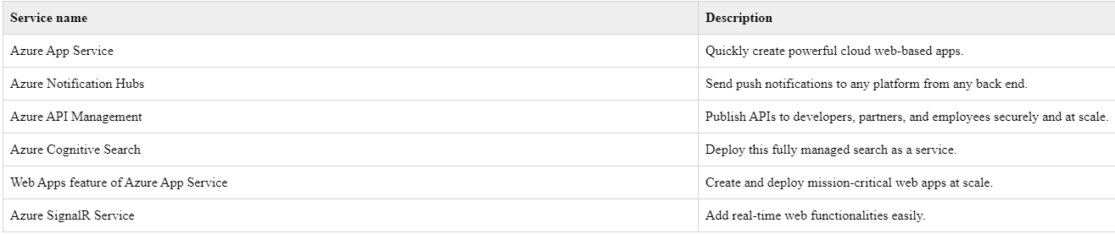

**IoT**

People are able to access more information than ever before. Personal digital assistants led to smartphones, and now there are smart watches, smart thermostats, and even smart refrigerators. Personal computers used to be the norm. Now the internet allows any item that's online-capable to access valuable information. This ability for devices to garner and then relay information for data analysis is referred to as IoT.

Many services can assist and drive end-to-end solutions for IoT on Azure.

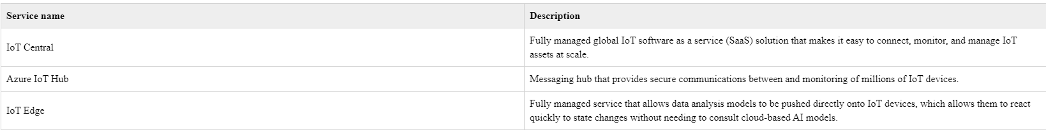

**Big data**

Data comes in all formats and sizes. When we talk about big data, we're referring to *large* volumes of data. Data from weather systems, communications systems, genomic research, imaging platforms, and many other scenarios generate hundreds of gigabytes of data. This amount of data makes it hard to analyze and make decisions. It's often so large that traditional forms of processing and analysis are no longer appropriate.

Open-source cluster technologies have been developed to deal with these large data sets. Azure supports a broad range of technologies and services to provide big data and analytic solutions.

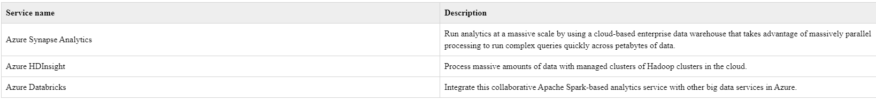

Get started with Azure accounts

What is the Azure free account?

The Azure free account includes:

* Free access to popular Azure products for 12 months.
* A credit to spend for the first 30 days.
* Access to more than 25 products that are always free.

What is the Learn sandbox?

Many of the Learn exercises use a technology called the sandbox, which creates a temporary subscription that's added to your Azure account. This temporary subscription allows you to create Azure resources for the duration of a Learn module. Learn automatically cleans up the temporary resources for you after you've completed the module.

When you're completing a Learn module, you're welcome to use your personal subscription to complete the exercises in a module. The sandbox is the preferred method to use though, because it allows you to create and test Azure resources at no cost to you.

**Cloud models**

What are public, private, and hybrid clouds?

There are three deployment models for cloud computing: *public cloud*, *private cloud*, and *hybrid cloud*. Each deployment model has different aspects that you should consider as you migrate to the cloud.

**Public cloud:** Services are offered over the public internet and available to anyone who wants to purchase them. Cloud resources, such as servers and storage, are owned and operated by a third-party cloud service provider, and delivered over the internet.

**Private cloud:** A private cloud consists of computing resources used exclusively by users from one business or organization. A private cloud can be physically located at your organization's on-site (on-premises) datacenter, or it can be hosted by a third-party service provider.

**Hybrid cloud:** A hybrid cloud is a computing environment that combines a public cloud and a private cloud by allowing data and applications to be shared between them.

**Cloud model comparison:**

Public cloud

* No capital expenditures to scale up.
* Applications can be quickly provisioned and deprovisioned.
* Organizations pay only for what they use.

Private cloud

* Hardware must be purchased for start-up and maintenance.
* Organizations have complete control over resources and security.
* Organizations are responsible for hardware maintenance and updates.

Hybrid cloud

* Provides the most flexibility.
* Organizations determine where to run their applications.
* Organizations control security, compliance, or legal requirements.

Cloud benefits and considerations

What are some cloud computing advantages?

There are several advantages that a cloud environment has over a physical environment that Tailwind Traders can use following its migration to Azure.

* **High availability**: Depending on the service-level agreement (SLA) that you choose, your cloud-based apps can provide a continuous user experience with no apparent downtime, even when things go wrong.
* **Scalability**: Apps in the cloud can scale *vertically* and *horizontally*:
  + Scale vertically to increase compute capacity by adding RAM or CPUs to a virtual machine.
  + Scaling horizontally increases compute capacity by adding instances of resources, such as adding VMs to the configuration.
* **Elasticity**: You can configure cloud-based apps to take advantage of autoscaling, so your apps always have the resources they need.
* **Agility**: Deploy and configure cloud-based resources quickly as your app requirements change.
* **Geo-distribution**: You can deploy apps and data to regional datacenters around the globe, thereby ensuring that your customers always have the best performance in their region.
* **Disaster recovery**: By taking advantage of cloud-based backup services, data replication, and geo-distribution, you can deploy your apps with the confidence that comes from knowing that your data is safe in the event of disaster.

Capital expenses vs. operating expenses

There are two different types of expenses that you should consider:

* **Capital Expenditure (CapEx)** is the up-front spending of money on physical infrastructure, and then deducting that up-front expense over time. The up-front cost from CapEx has a value that reduces over time.
* **Operational Expenditure (OpEx)** is spending money on services or products now, and being billed for them now. You can deduct this expense in the same year you spend it. There is no up-front cost, as you pay for a service or product as you use it.

In other words, when Tailwind Traders owns its infrastructure, it buys equipment that goes onto its balance sheets as assets. Because a capital investment was made, accountants categorize this transaction as a CapEx. Over time, to account for the assets' limited useful lifespan, assets are depreciated or amortized.

Cloud services, on the other hand, are categorized as an OpEx, because of their consumption model. There's no asset for Tailwind Traders to amortize, and its cloud service provider (Azure) manages the costs that are associated with the purchase and lifespan of the physical equipment. As a result, OpEx has a direct impact on net profit, taxable income, and the associated expenses on the balance sheet.

To summarize, CapEx requires significant up-front financial costs, as well as ongoing maintenance and support expenditures. By contrast, OpEx is a consumption-based model, so Tailwind Traders is only responsible for the cost of the computing resources that it uses.

Cloud computing is a consumption-based model

Cloud service providers operate on a *consumption-based model*, which means that end users only pay for the resources that they use. Whatever they use is what they pay for.

A consumption-based model has many benefits, including:

* No upfront costs.
* No need to purchase and manage costly infrastructure that users might not use to its fullest.
* The ability to pay for additional resources when they are needed.
* The ability to stop paying for resources that are no longer needed.

**Cloud services**

**IaaS (***Infrastructure-as-a-Service):* This cloud service model is the closest to managing physical servers; a cloud provider will keep the hardware up-to-date, but operating system maintenance and network configuration is up to you as the cloud tenant. For example, Azure virtual machines are fully operational virtual compute devices running in Microsoft datacenters. An advantage of this cloud service model is rapid deployment of new compute devices. Setting up a new virtual machine is considerably faster than procuring, installing, and configuring a physical server.

**PaaS (***Platform-as-a-Service):* This cloud service model is a managed hosting environment. The cloud provider manages the virtual machines and networking resources, and the cloud tenant deploys their applications into the managed hosting environment. For example, Azure App Services provides a managed hosting environment where developers can upload their web applications, without having to worry about the physical hardware and software requirements.

**SaaS (***Software-as-a-Service):* In this cloud service model, the cloud provider manages all aspects of the application environment, such as virtual machines, networking resources, data storage, and applications. The cloud tenant only needs to provide their data to the application managed by the cloud provider. For example, Microsoft Office 365 provides a fully working version of Microsoft Office that runs in the cloud. All you need to do is create your content, and Office 365 takes care of everything else.

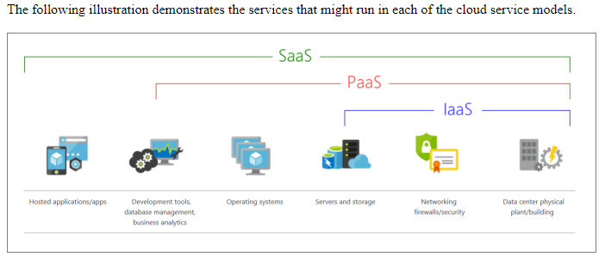

IaaS

IaaS is the most flexible category of cloud services. It aims to give you complete control over the hardware that runs your application. Instead of buying hardware, with IaaS, you rent it.

Advantages

**No CapEx**. Users have no up-front costs.

**Agility**. Applications can be made accessible quickly, and deprovisioned whenever needed.

**Management**. The shared responsibility model applies; the user manages and maintains the services they have provisioned, and the cloud provider manages and maintains the cloud infrastructure.

**Consumption-based model**. Organizations pay only for what they use and operate under an Operational Expenditure (OpEx) model.

**Skills**. No deep technical skills are required to deploy, use, and gain the benefits of a public cloud. Organizations can use the skills and expertise of the cloud provider to ensure workloads are secure, safe, and highly available.

**Cloud benefits**. Organizations can use the skills and expertise of the cloud provider to ensure workloads are made secure and highly available.

**Flexibility**. IaaS is the most flexible cloud service because you have control to configure and manage the hardware running your application.

PaaS

PaaS provides the same benefits and considerations as IaaS, but there are some additional benefits to be aware of.

Advantages

**No CapEx**. Users have no up-front costs.

**Agility**. PaaS is more agile than IaaS, and users don't need to configure servers for running applications.

**Consumption-based model**. Users pay only for what they use, and operate under an OpEx model.

**Skills**. No deep technical skills are required to deploy, use, and gain the benefits of PaaS.

**Cloud benefits**. Users can take advantage of the skills and expertise of the cloud provider to ensure that their workloads are made secure and highly available. In addition, users can gain access to more cutting-edge development tools. They can then apply these tools across an application's lifecycle.

**Productivity**. Users can focus on application development only, because the cloud provider handles all platform management. Working with distributed teams as services is easier because the platform is accessed over the internet. You can make the platform available globally more easily.

Disadvantage

**Platform limitations**. There can be some limitations to a cloud platform that might affect how an application runs. When you're evaluating which PaaS platform is best suited for a workload, be sure to consider any limitations in this area.

SaaS

SaaS is software that's centrally hosted and managed for you and your users or customers. Usually one version of the application is used for all customers, and it's licensed through a monthly or annual subscription.

SaaS provides the same benefits as IaaS, but again there are some additional benefits to be aware of too.

Advantages

**No CapEx**. Users have no up-front costs.

**Agility**. Users can provide staff with access to the latest software quickly and easily.

**Pay-as-you-go pricing model**. Users pay for the software they use on a subscription model, typically monthly or yearly, regardless of how much they use the software.

**Skills**. No deep technical skills are required to deploy, use, and gain the benefits of SaaS.

**Flexibility**. Users can access the same application data from anywhere.

Disadvantage

**Software limitations**. There can be some limitations to a software application that might affect how users work. Because you're using as-is software, you don't have direct control of features. When you're evaluating which SaaS platform is best suited for a workload, be sure to consider any business needs and software limitations.

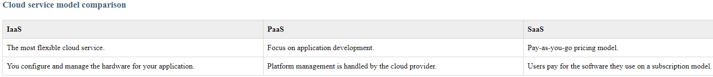

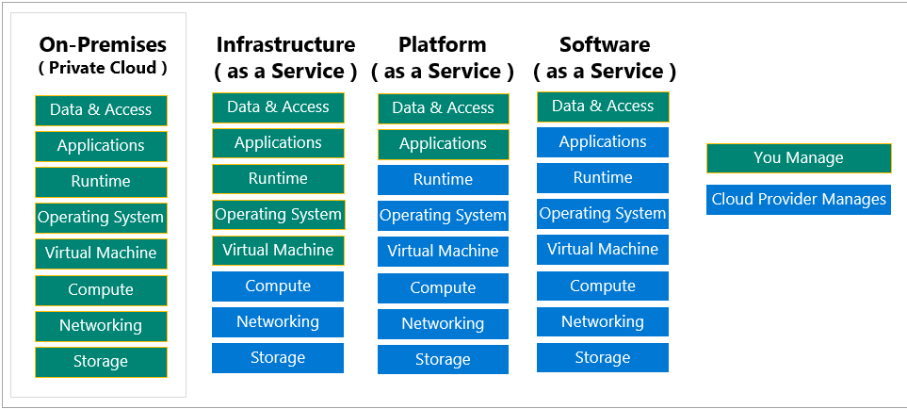

What is serverless computing?

Like PaaS, *serverless computing* enables developers to build applications faster by eliminating the need for them to manage infrastructure. With serverless applications, the cloud service provider automatically provisions, scales, and manages the infrastructure required to run the code. Serverless architectures are highly scalable and event-driven, only using resources when a specific function or trigger occurs.

It's important to note that servers are still running the code. The “serverless” name comes from the fact that the tasks associated with infrastructure provisioning and management are invisible to the developer. This approach enables developers to increase their focus on the business logic, and deliver more value to the core of the business. Serverless computing helps teams increase their productivity and bring products to market faster, and it allows organizations to better optimize resources and stay focused on innovation.

**Overview of Azure subscriptions, management groups, and resources**

you need to learn the organizing structure for resources in Azure, which has four levels: management groups, subscriptions, resource groups, and resources.

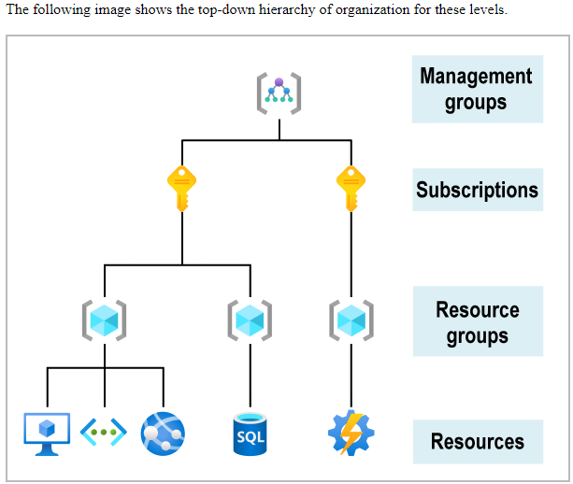

**Resources**: Resources are instances of services that you create, like virtual machines, storage, or SQL databases.

**Resource groups**: Resources are combined into resource groups, which act as a logical container into which Azure resources like web apps, databases, and storage accounts are deployed and managed.

**Subscriptions**: A subscription groups together user accounts and the resources that have been created by those user accounts. For each subscription, there are limits or quotas on the amount of resources that you can create and use. Organizations can use subscriptions to manage costs and the resources that are created by users, teams, or projects.

**Management groups**: These groups help you manage access, policy, and compliance for multiple subscriptions. All subscriptions in a management group automatically inherit the conditions applied to the management group.

**Azure regions, availability zones, and region pairs:**

**Azure regions:** A *region* is a geographical area on the planet that contains at least one but potentially multiple datacenters that are nearby and networked together with a low-latency network. Azure intelligently assigns and controls the resources within each region to ensure workloads are appropriately balanced.

***Important:****Some services or VM features are only available in certain regions, such as specific VM sizes or storage types. There are also some global Azure services that don't require you to select a particular region, such as Azure Active Directory, Azure Traffic Manager, and Azure DNS.*

**Why are regions important?** Azure has more global regions than any other cloud provider. These regions give you the flexibility to bring applications closer to your users no matter where they are. Global regions provide better scalability and redundancy. They also preserve data residency for your services.

**Special Azure regions**

Azure has specialized regions that you might want to use when you build out your applications for compliance or legal purposes. A few examples include:

* **US DoD Central, US Gov Virginia, US Gov Iowa and more:** These regions are physical and logical network-isolated instances of Azure for U.S. government agencies and partners. These datacenters are operated by screened U.S. personnel and include additional compliance certifications.
* **China East, China North, and more:** These regions are available through a unique partnership between Microsoft and 21Vianet, whereby Microsoft doesn't directly maintain the datacenters.

**What is an availability zone?**

Availability zones are physically separate datacenters within an Azure region. Each availability zone is made up of one or more datacenters equipped with independent power, cooling, and networking. An availability zone is set up to be an *isolation boundary*. If one zone goes down, the other continues working. Availability zones are connected through high-speed, private fiber-optic networks.

